With the HTML DOM, JavaScript can access and change all the elements of an HTML document.

The HTML DOM (Document Object Model)

When a web page is loaded, the browser creates a **D**ocument **O**bject **M**odel of the page.

The **HTML DOM** model is constructed as a tree of **Objects**:

The HTML DOM Tree of Objects

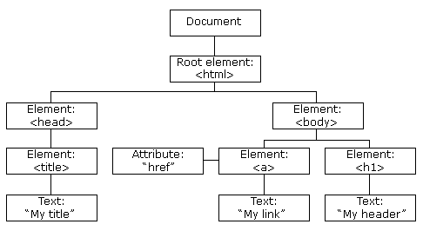

With the object model, JavaScript gets all the power it needs to create dynamic HTML:

* JavaScript can change all the HTML elements in the page
* JavaScript can change all the HTML attributes in the page
* JavaScript can change all the CSS styles in the page
* JavaScript can remove existing HTML elements and attributes
* JavaScript can add new HTML elements and attributes
* JavaScript can react to all existing HTML events in the page
* JavaScript can create new HTML events in the page

What You Will Learn

In the next chapters of this tutorial you will learn:

* How to change the content of HTML elements
* How to change the style (CSS) of HTML elements
* How to react to HTML DOM events
* How to add and delete HTML elements

ADVERTISEMENT

What is the DOM?

The DOM is a W3C (World Wide Web Consortium) standard.

The DOM defines a standard for accessing documents:

*"The W3C Document Object Model (DOM) is a platform and language-neutral interface that allows programs and scripts to dynamically access and update the content, structure, and style of a document."*

The W3C DOM standard is separated into 3 different parts:

* Core DOM - standard model for all document types
* XML DOM - standard model for XML documents
* HTML DOM - standard model for HTML documents

What is the HTML DOM?

The HTML DOM is a standard **object** model and **programming interface** for HTML. It defines:

* The HTML elements as **objects**
* The **properties** of all HTML elements
* The **methods** to access all HTML elements
* The **events** for all HTML elements

In other words:**The HTML DOM is a standard for how to get, change, add, or delete HTML elements.**